MYSQL DATABASE PROJECT

What is SQL?

**SQL** stands for **Structured Query Language** which is a computer language for storing, manipulating and retrieving data stored in a relational database.

SQL is the standard language to communicate with Relational Database Systems. All the Relational Database Management Systems (RDMS) like MySQL, MS Access, Oracle, Sybase, Informix, Postgres and SQL Server use SQL as their Standard Database Language.

Syntax and Queries:

1. The First step in SQL is to have a Database. The Database is a place where all the data is stored and can be fetched for the different purpose.

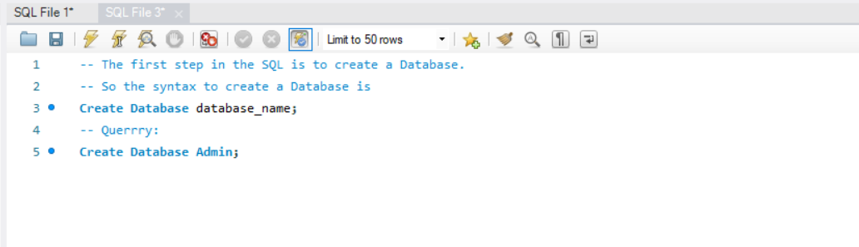So the first query and the syntax of Creating a Database:

Output :

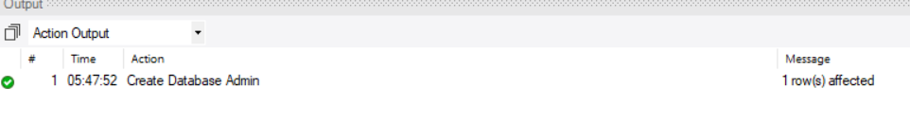

The Database with the name of Admin has been created. Now we can create different tables into this database and store data in this database.

1. Create Table:

The Next step is to create is table in the database.

Query:

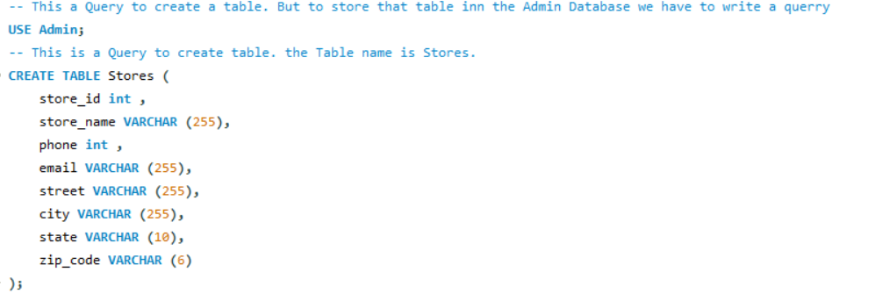

Output:

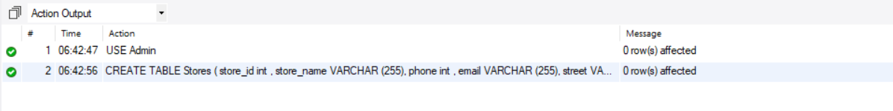

The Table with the name of Stores is created and the Column names is also given and the characters for each column is also mentioned and the length for the each column characters is also mentioned.

The Next step will be to enter the values in the Columns of the Table.

1. Insert values:

The Next Steps is to insert the values into the table which we created. The command which we use to inset a value into a table is “INSERT INTO”.

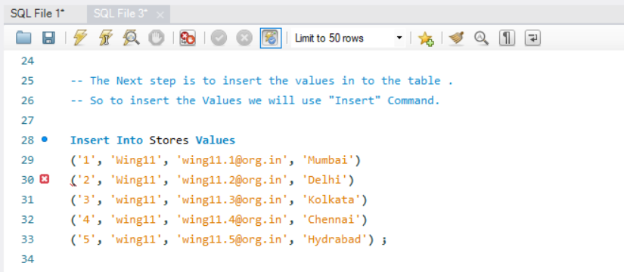Query:

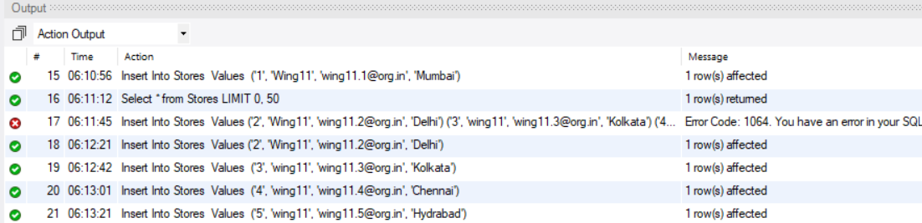Output:

The Values in the table name “Stores” has been inserted in the form of Rows. So while writing a query the each value was entered in the sequence of the columns so that the values are properly assigned in the columns.

1. Select values:

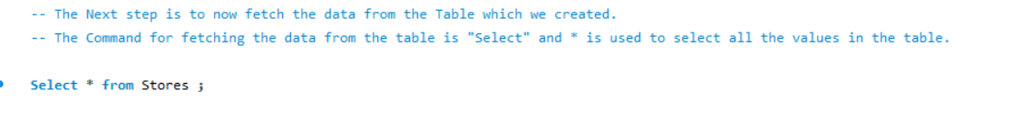The next Step is to Select the values from the table which we created. To fetch all the Data from the table the “Select” Command should be used.

Output:

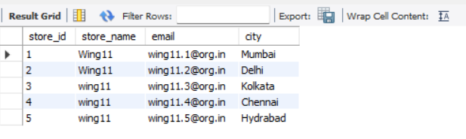

The Result for the above query is to fetch the data from the table which we created. The Select command can be used to fetch any data from any table present in the database. And the‘*’ is used to select all the values inside the table.

If we want to fetch any particular column from the table then we have to write the column name instead of ‘*’ in the query. Example we want to fetch only the ‘CITY’ Column from table.

Output:

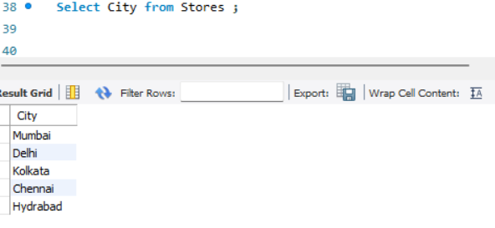

1. WHERE Clause:

Now we are going to use WHERE clause in this query. WHERE clause is used to filter a particular data based on an given condition.

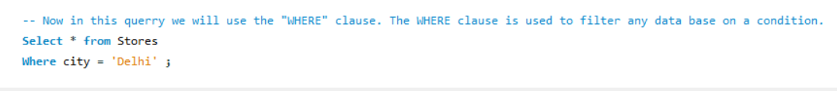

Output:

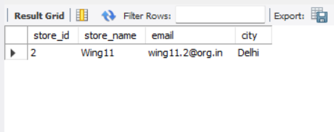

In the above result we have used a Where clause and have given a condition in the query to fetch the row which have the city name as Delhi. So using WHERE clause we are wring the query and condition in the query to fetch the row which have city name Delhi.

1. DISTINCT Operator:

This is the type of Operator in SQL which is used to display the unique records from the table. The “DISTINCT” Operator only fetch the one single record from the duplicate records present in the table. This is one of the most important operators in the SQL.



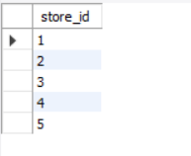Output: Here is the all unique values fetched from the ‘store_id’ column.